Computer Graphics Star Rotation

In my assignment I have chosen to do the Archimedean Spiral.

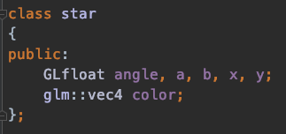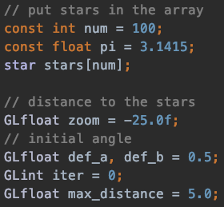

First I have created a class called star to declare variable to be used in our logarithmic spiral formula.

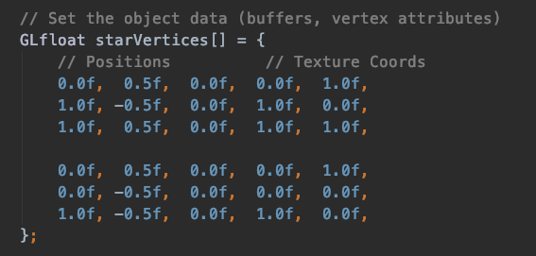

Set the star vertices for our star.bmp file

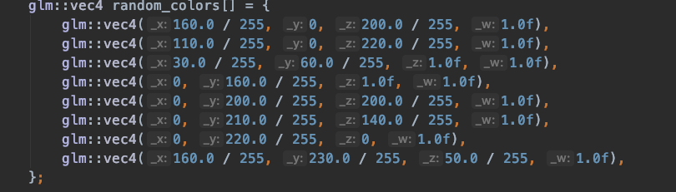

Get random colours from our stars. I couldn’t figure how to use a randomizer function that would do it for me. I have seen examples codes which randomized r g b but I was unable to implement it somehow so I manually added some colours which isn’t that efficient.

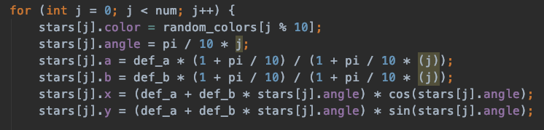

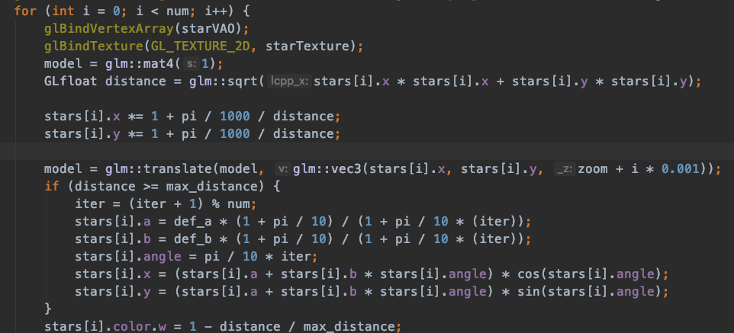

I have set the maximum number of stars to a 100 so the program will run until it computes 100 stars.

When I ran the code, it was working fine but since I am using a MacBook Air. The GPU isn’t good enough to perform the task faster. Also, OpenGL doesn’t really run well on MAC OS.

I have refenced form this link to create the Archimedean Spiral Equation it was easy to understand and simple enough to reference it from <https://www.sciencefacts.net/archimedean-spiral.html>

